HKISPA PRESS RELEASE
14th June 2002
Implementation of the HKISPA Anti-Spam Code of Practice
HKISPA has started promoting its Anti-Spam Code of Practice (http://www.hkispa.org.hk/antispam/cop.html, CoP) to ISPs in Hong Kong since February 2000. The CoP is a set of administrative and technical recommendations that, when adopted by ISPs, reduces the amount of junk e-mails (SPAM) received by customers and minimizes the chance of ISPs’ services being abused for transmission of SPAM, while not affecting the quality of service offered to customers.
HKISPA holds a strong stance against any form of Internet abuse and endeavors all possible measures to make using the Internet both pleasurable and safe. Members of HKISPA, which include most ISPs in Hong Kong, are working together to fight against one of the most serious Internet abuse, SPAM. The CoP is one of our collective efforts against SPAM. We are glad to learn that the CoP is being progressively adopted by major ISPs in Hong Kong.
Adoption of the CoP requires good planning and prior communication with customers to ensure that customers with special requirements are catered for properly. Although there were complaints recently from customers of Netvigator about service interruptions due to insufficient communication, HKISPA is confident that Netvigator and all ISPs in Hong Kong can adopt the CoP at their own specific situations smoothly such that customers will soon have higher quality Internet service with lesser SPAM.

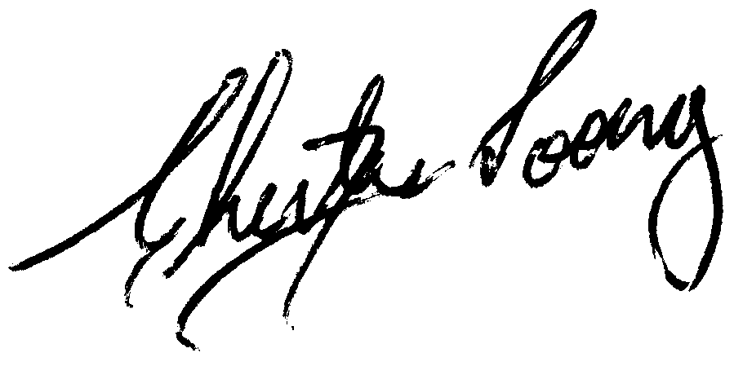
Chester Soong
Chairman
Hong Kong Internet Service Providers Association

About HKISPA
Hong Kong Internet Service Providers Association was established in November 1996. Its current membership base of 73 members covers most Internet Service Providers in Hong Kong. Missions of HKISPA include promotion of Internet development in Hong Kong, promotion of fair competition, representing the Hong Kong ISP industry to work with various parties and government agencies such as OFTA, Police, TELA, etc. on Internet related issues. More information is available at http://www.hkispa.org.hk/

Media Contact
Ms. Esther Chan, HKISPA Coordinator
Telephone: 2803-2669, e-mail: esther@hkispa.org.hk

